Reading the Tea Leaves: Starbucks Debuts Teavana Concept Store in NYC
October 28, 2013 2:48 PM
Always thirsty for hot new markets, Starbucks is betting big on tea. The coffee giant recently spent $612 million to acquire Atlanta-based Teavana Holdings, and is not letting its newest subsidiary steep. We sent writer Nancy Lazarus to see what’s brewing at the first-ever Teavana concept store, complete with tea bar, a “curated” loose leaf tea section, and tea-inspired foods.
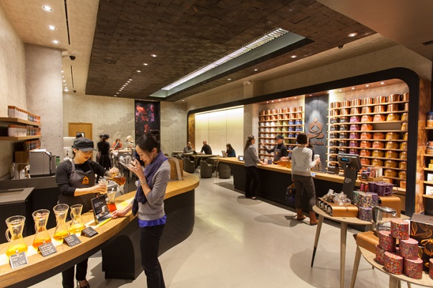
(Photos courtesy Starbucks Corporation)
“Teavana is a twist on beverages, and changes the idea of how people think of tea,” said Chanda Beppu, strategy and business innovation director for global tea at Starbucks. It’s also designed to broaden how customers think about the brand.
Starbucks acquired Teavana and its more than 300 retail locations in January, and last week unveiled the first “Teavana Fine Teas + Tea Bar” on Manhattan’s Upper East Side (on Madison Avenue at 85th Street). With an assortment of 100 Asian-inspired flavors and a coveted location near Museum Mile and Central Park, Starbucks is also looking for New Yorkers, tourists, art lovers, runners, and passersby to warm to the concept store. “We’re still learning,” said Starbucks chief creative office Arthur Rubinfeld during Wednesday’s press preview, “and we’ll see how much of a community gathering spot this becomes.”
For Starbucks, it’s all about local relevant design, and textures are key, added Rubinfeld. Starbucks’ creative director of global design, Liz Muller, led a tour of the multifaceted venue, divided into distinct sections. “Here we wanted to create a tranquil, calm, zen-like ambience,” noted Muller. “Tea is the speaking point, and the store is in the background.”
“At the entrance visitors are greeted by a wall of teas,” said Muller. “As they continue inside, they’ll see an illuminated countertop and a menu board on the left side. Wall graphics include hibiscus lit in color, with wallpaper in muted tones. The solid wraparound countertops are made of recycled oak wood, and we used lower club seating for guests. The food case is like a jewel box, taking a European approach,” On the far side of the entrance is a colorful merchandise display.
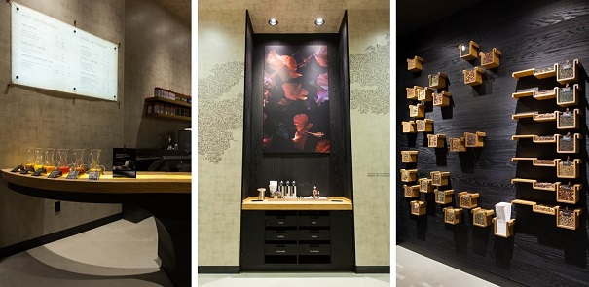
The ceiling is another focal point, made of black wood based on a Japanese charcoaling technique. Charcoal making was also part of the ancient Asian ritual for tea brewing, Muller explained. Loose tea leaves encased in glass are embedded in the ceiling. As Beppu said on opening day, “The ceiling has been a point of customer interest since it offers an unexpected design element.”
The innovative equipment is also intended to surprise tea bar guests, Rubinfeld added. He pointed out the reverse atmospheric tea maker. There’s also a machine to carbonate tea drinks that contains recipes for adjustable carbonation. Texture has been added to the insulated cups that have mod-style white lids and copper-colored straws.
The menus encourage customized food and beverage pairings, and “tea partners” (or “teaologists”) lend their expertise with flavor profiles. Tea options include sparkling, craft, fusion, and tea lattes, along with a lengthy list of alluring names. Examples include “silver needle,” “lavender dreams,” “snow geisha,” “Moroccan mint,” and celebratory-sounding options such as “sangria punch” and “berry kiwi colada.” Naturally, since it’s October and this is a Starbucks experience, there’s also “pumpkin spice brûlée” tea.
Nancy Lazarus’s is a frequent contributor to UnBeige

